EXPERIMENT NO. 1: LOCAL LIBRARY MANAGEMENT SYSTEM
AIM:
To design and develop a responsive web application for a Local Library Management System that enables book catalog searching, borrowing and return management, fine calculation, and administrative control over books and semester materials.
PSEUDOCODE (IN 6 SIMPLE POINTS):
Step 1: Initialize the system with catalog data containing book titles, authors, categories, and availability status.
Step 2: Display an intuitive user interface with navigation tabs for Book Catalog, Student Borrow Dashboard, Fine Calculator, and Admin Portal.
Step 3: Implement a real-time search filter allowing users to search books by title, author, or semester-wise study material.
Step 4: Record student borrowing transactions by capturing student ID, book title, issue date, and setting an automated return due date.
Step 5: Calculate overdue fines dynamically by determining days elapsed past the due date multiplied by the daily fine rate.
Step 6: Enable librarian administrative functions to add new books, update/delete existing records, and upload semester study materials.
CODE:
<!DOCTYPE html>
<html lang="en">
<head>
<meta charset="UTF-8">
<title>Local Library Management System</title>
<style>
body { font-family: 'Segoe UI', Arial, sans-serif; margin: 0; background: #f0f2f5; color: #333; }
header { background: #1a365d; color: white; padding: 18px 30px; display: flex; justify-content: space-between; align-items: center; }
.container { max-width: 1000px; margin: 25px auto; padding: 20px; background: white; border-radius: 8px; box-shadow: 0 2px 10px rgba(0,0,0,0.1); }
.tabs { display: flex; gap: 10px; margin-bottom: 20px; border-bottom: 2px solid #e2e8f0; }
.tab-btn { padding: 10px 20px; cursor: pointer; border: none; background: none; font-weight: 600; color: #4a5568; }
.tab-btn.active { color: #2b6cb0; border-bottom: 3px solid #2b6cb0; }
.panel { display: none; }
.panel.active { display: block; }
input, select, button { padding: 10px; margin: 6px 0; border: 1px solid #cbd5e0; border-radius: 4px; box-sizing: border-box; }
button { background: #2b6cb0; color: white; border: none; cursor: pointer; font-weight: bold; }
button:hover { background: #1a4971; }
table { width: 100%; border-collapse: collapse; margin-top: 15px; }
th, td { border: 1px solid #e2e8f0; padding: 10px; text-align: left; }
th { background: #edf2f7; color: #2d3748; }
.fine-badge { background: #fed7d7; color: #9b2c2c; padding: 4px 8px; border-radius: 4px; font-weight: bold; }
</style>
</head>
<body>
<header>
<h2>Central Library Portal</h2>
<span>Role: Student / Admin</span>
</header>
<div class="container">
<div class="tabs">
<button class="tab-btn active" onclick="showTab('catalog')">Book Catalog</button>
<button class="tab-btn" onclick="showTab('borrow')">Borrow & Return</button>
<button class="tab-btn" onclick="showTab('fine')">Calculate Fine</button>
<button class="tab-btn" onclick="showTab('admin')">Librarian Admin</button>
</div>
<!-- Catalog Tab -->
<div id="catalog" class="panel active">
<input type="text" id="searchBox" placeholder="Search by Book Title or Subject..." onkeyup="filterBooks()" style="width: 100%;">
<table id="bookTable">
<thead><tr><th>ID</th><th>Book Title</th><th>Author</th><th>Semester</th><th>Status</th></tr></thead>
<tbody>
<tr><td>B101</td><td>Data Structures & Algorithms</td><td>Mark Allen</td><td>Sem 3</td><td>Available</td></tr>
<tr><td>B102</td><td>Internet Programming Essentials</td><td>Paul Deitel</td><td>Sem 5</td><td>Available</td></tr>
<tr><td>B103</td><td>Database System Concepts</td><td>Silberschatz</td><td>Sem 4</td><td>Issued</td></tr>
</tbody>
</table>
</div>
<!-- Borrow & Return Tab -->
<div id="borrow" class="panel">
<h3>Issue Book to Student</h3>
<form id="issueForm" onsubmit="issueBook(event)">
<input type="text" id="studentId" placeholder="Student Roll No" required style="width: 48%;">
<input type="text" id="issueBookId" placeholder="Book ID (e.g., B101)" required style="width: 48%;"><br>
<label>Issue Date: </label><input type="date" id="issueDate" required>
<label>Return Due Date: </label><input type="date" id="dueDate" required><br>
<button type="submit">Issue Book</button>
</form>
<div id="issueStatus" style="margin-top: 15px; color: green; font-weight: bold;"></div>
</div>
<!-- Fine Calculator Tab -->
<div id="fine" class="panel">
<h3>Overdue Fine Calculation</h3>
<p>Fine Policy: Rs. 5 per day after due date.</p>
<label>Due Date: </label><input type="date" id="calcDueDate">
<label>Actual Return Date: </label><input type="date" id="calcReturnDate"><br>
<button onclick="calculateFine()">Check Fine</button>
<div id="fineResult" style="margin-top: 15px;"></div>
</div>
<!-- Admin Tab -->
<div id="admin" class="panel">
<h3>Add New Book to Inventory</h3>
<input type="text" id="newTitle" placeholder="Book Title" style="width: 48%;">
<input type="text" id="newAuthor" placeholder="Author Name" style="width: 48%;"><br>
<select id="newSem" style="width: 48%;">
<option value="Sem 1">Semester 1</option>
<option value="Sem 3">Semester 3</option>
<option value="Sem 5">Semester 5</option>
</select>
<button onclick="addBook()">Add Book to Catalog</button>
</div>
</div>
<script>
function showTab(tabId) {
document.querySelectorAll('.panel').forEach(p => p.classList.remove('active'));
document.querySelectorAll('.tab-btn').forEach(b => b.classList.remove('active'));
document.getElementById(tabId).classList.add('active');
event.target.classList.add('active');
}
function filterBooks() {
let filter = document.getElementById('searchBox').value.toUpperCase();
let tr = document.getElementById('bookTable').getElementsByTagName('tr');
for (let i = 1; i < tr.length; i++) {
let text = tr[i].innerText.toUpperCase();
tr[i].style.display = text.includes(filter) ? '' : 'none';
}
}
function issueBook(e) {
e.preventDefault();
let sid = document.getElementById('studentId').value;
let bid = document.getElementById('issueBookId').value;
let exp = document.getElementById('dueDate').value;
document.getElementById('issueStatus').innerText = `Success: Book ${bid} issued to Student ${sid}. Return Due Date: ${exp}`;
}
function calculateFine() {
let due = new Date(document.getElementById('calcDueDate').value);
let ret = new Date(document.getElementById('calcReturnDate').value);
let diffDays = Math.ceil((ret - due) / (1000 * 60 * 60 * 24));
if (diffDays > 0) {
let fine = diffDays * 5;
document.getElementById('fineResult').innerHTML = `<span class="fine-badge">Late by ${diffDays} days. Fine Amount: Rs. ${fine}</span>`;
} else {
document.getElementById('fineResult').innerHTML = '<span style="color: green; font-weight: bold;">Returned on time! No fine applicable.</span>';
}
}
function addBook() {
let title = document.getElementById('newTitle').value;
let author = document.getElementById('newAuthor').value;
let sem = document.getElementById('newSem').value;
if(!title || !author) return alert('Enter book details');
let tbody = document.getElementById('bookTable').getElementsByTagName('tbody')[0];
let row = tbody.insertRow();
row.innerHTML = `<td>B${Math.floor(100+Math.random()*900)}</td><td>${title}</td><td>${author}</td><td>${sem}</td><td>Available</td>`;
alert('Book added to inventory!');
document.getElementById('newTitle').value = '';
document.getElementById('newAuthor').value = '';
}
</script>
</body>
</html>

Output:
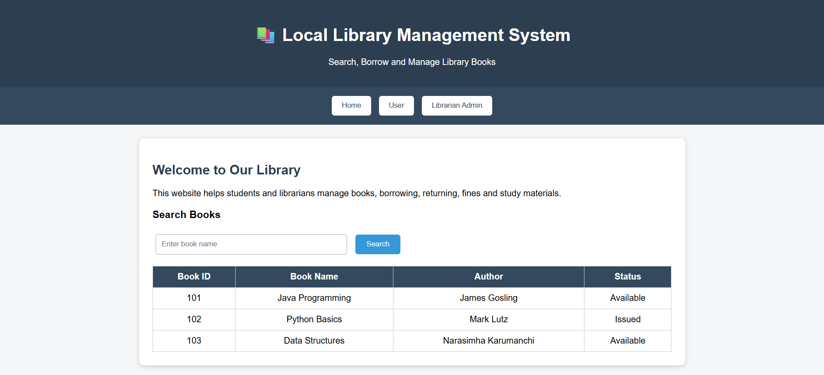
RESULT:
Thus, the web application for the Local Library Management System was successfully designed, developed, and verified with catalog search, book issue/return tracking, fine calculation, and administrative inventory controls.

